S-ISA-64 Device Standard
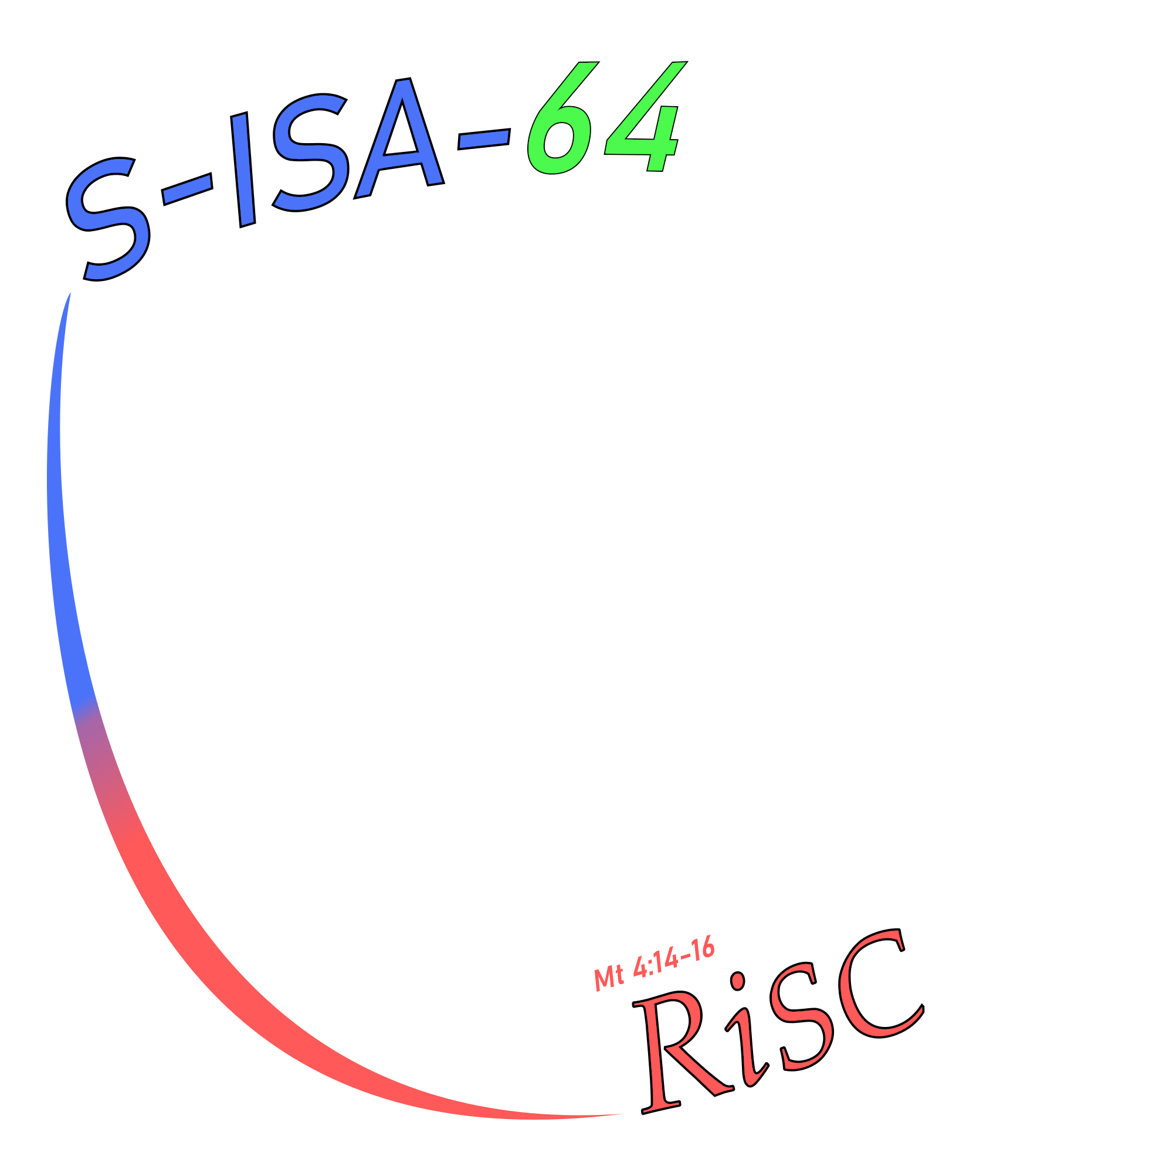
Contents
Overview 3
Prerequisite Terminology and Concepts 4
Device Interaction- Execution Flow 5
Default Device Behavior 6
Device Descriptor Table Format 10
Device Descriptor Identifiers 12
Multiprocessor Essentials 13

Overview
S-ISA-64 accesses non-RAM components through two instructions: the dread and dwrite instructions, which send data and commands on a special bus dedicated for interacting with peripheral components.

The Programmer’s Manual covers the overall functionality of these two instructions in the instruction set, while this document aims to document how components on the system (such as non-volatile storage, a graphics card, keyboard, display, microphone, ethernet controller, or USB hub). Are discovered and interacted with in terms of dread and dwrite.

It also documents the errata of multi-threaded access to the device bus and what interactions must be implemented.

The Programmer’s Manual is considered a Necessary Companion for understanding this document.

Prerequisite Terminology and Concepts
This is what this whole document is actually about:

dread- instruction in the S-ISA-64 instruction set which reads 64 bits from a device on the device bus- a special address space which behaves like memory that can be read or written to. The actual instruction takes a single register ID operand and writes the return value to the same, but the effective functionality is to take in an address and return a 64 bit integer. Thus, the prototype is

uint64 dread(uint64 address);
dwrite- instruction in the S-ISA-64 instruction set which writes 64 bits to a device on the device bus. The actual instruction takes two register ID’s as operands, but the effective functionality is to pass in an address and a value, and return nothing. Thus, the prototype is:

void dwrite(uint64 address, uint64 val);

These two operations form the basis of all interactions with components (excluding main memory) on the system. Components on the system may also be configured (through dwrite operations) to take data from main memory, if supported. (How devices with such functionality behave and how they are configured shall be documented in this standard.)

This document’s primary goal is to create a hardware-software interaction standard for the S-ISA-64 architecture before hundreds of hours of work has been spent to design the actual hardware, the emulator, operating system development kit, and system libraries.

Unless otherwise specified, Anything called an “address” in this document is an address on the device bus and not a main-memory address.
Device Interaction- Execution Flow
Upon boot, the operating system on the computer will check its own memory size by reading address 1, check for the presence of standards-compliant coprocessor cores in address 3, and mutual exclusion devices (“mutexes”) in address 5. Using these values, if applicable, it may read the pointer to the processor kickstart addresses in address 4. After reading 1 and 4, the operating system may also try to use one of the processor kickstart addresses to start a secondary core. How processor kickstart addresses work shall be documented later. It may also read the pointer to the Mutual Exclusion Device Addresses in Address 6. It may also try to retrieve the starting address of Processor Status Variables from Address 7.
Here, we have our first standard rules:
1. The memory size and millisecond clock functionalities of addresses 1 and 2 are considered vital to a system and shall not be absent or mangled in a compliant implementation.
2. Any unimplemented addresses from 0 to 8 inclusive, which are not implemented as according to this standard, shall safely return zero, which is considered the error value.

Finally, and most importantly, the operating system may search for device descriptors by checking address 8, and if the return value is non-zero it may check the device descriptor address array starting at 0x100.

3. If there are no peripheral device descriptor tables on the system, the return value of reading address 8 on the device bus shall be zero.
4. If the return value of address 8 is non-zero, then reading addresses starting at 0x100 shall return pointers to standards-compliant device descriptors.

Each device descriptor table may be queried and interacted with according to the standard, and the complete tree (as other device descriptor tables may be provided) may be searched.
Default Device Behavior
The default devices in addresses 0-5 are considered vital to the functionality of the S-ISA-64 implementation, especially 1 and 2. It is safe to assume that addresses 1 and 2 will always be available and function normally unless specifically configured otherwise through device descriptors.

Serial IO Device (Address 0)
The Serial I/O device provides blocking read/write of ASCII character values for debugging purposes. It is not considered essential for a S-ISA-64 implementation as its primary purpose is debugging, but this address must only be used for that purpose. When dread is invoked on the address, the processor is halted until a value is retrieved from the input device. An 8-bit ASCII character (the bottom 7 being the 7-bit ASCII standard) value is returned in the bottom 8 bits of the 64 bit return value. When dwrite is invoked on the address, the bottom 8 bits of the input are treated as an 8-bit ASCII value, and should be displayed, transmitted, or broadcast as such to the appropriate serial port.

Memory Size (Address 1)
The Memory Size query device returns the amount of available system RAM for the implementation. Writing to this address is undefined behavior, but reading it shall return the number of available addressable contiguous bytes to the S-ISA-64 processor starting at address zero.

Clock Device (Address 2)
The Clock device returns a measure of the number of milliseconds passed since some point in the past to the caller on a dread. It must provide at least 32 bits of wrap-around (It may wrap around every 4,294,967.296 seconds).

Processor Count Device (Address 3)
The processor count device returns the number of available compliant processors on the system, which is dubbed Np. If the implementation is single-threaded, it may return either 0 (unimplemented) or 1. The behavior of Processors shall be documented in Multiprocessor Essentials.

Processor Kickstart Address Array Address Device (Address 4)

Reading address 4 shall return a valid device bus address (Dubbed “Kickstart[0]”), which, if written to, attempts to start the first processor on the system (Which is the boot processor). The next address (“Kickstart[1]”) attempts to start the second processor on the system, if available, and so on, up to Kickstart[Np-1] where Np is the number of compliant processors on the system, as provided by address 3.

If there are no available kickstart addresses, or they are unimplemented, Address 4 shall return 0.

If reading address 3 returns 0, then reading address 4 must also return 0.

Mutual Exclusion Device Count Device (Address 5)

Address 5 shall return the number of available contiguous mutual exclusion devices on the system, which is dubbed Nm. If none are available, zero is returned.

Mutual Exclusion Device Array Address Device (Address 6)

Address 6 shall return a valid device bus address (Dubbed “Mutex[0]”), which, if a value of 0 is written to it, shall attempt to “unlock” it. And if a value of 1 is written to it, shall attempt to “lock” it. Writing other values is implementation defined behavior. The next address, (“Mutex[1]”) shall behave identically to Mutex[0] if Nm is at least 2.

If reading address 5 returns 0, then address 6 must also return 0.

Processor Status Variable Array Address Device (Address 7)

Reading Address 7 shall return a valid device bus address (Dubbed “Pstat[0]”) which, if read, shall return a value indicating whether or not the processor is running and/or currently unavailable to be kickstarted by writing to its corresponding Kickstart address (which in this case would be Kickstart[0])

If the processor is running, and not able to be kickstarted, the value returned shall be 1.
if the processor is available to be kickstarted, the value returned shall be 0.
if the processor is for any reason unable to be kickstarted, the value returned shall be 0.

The next address, Pstat[1] shall behave identically to Pstat[0] if available.

The number of processor status variables, if implemented, must be at least as large as the number of processors, Np.

If the return value of Address 3 is zero, the return value of Address 7 must also be zero.
Device Descriptor Count Device (Address 8)
Address 8 shall yield the number of device descriptor tables whose device bus addresses are accessible by reading 0x100 (device bus) and onward.
The return value of Address 8 is dubbed “NeX”.

The return value may be zero if number of peripheral devices available on the system is zero.

If NeX is zero, then the operating system may safely assume that there are no peripherals on the system.

Device Descriptor Table Address Array (Addresses 0x100 – 0x100+NeX-1)

Addresses 0x100 (256 decimal) through 0x100 + NeX -1 shall return valid device bus addresses, each of which is the address of a Device Descriptor Table which is a series of contiguous device bus addresses that can be used to configure a device or query its properties. It may also provide the ability to interact with that device, and for some Device types, it may provide functionality not defined in this standard.
Device Descriptor Table Format
Every non-default device on the system, including virtual devices used only for configuring other devices, must expose itself using a “device descriptor table”.

What is a device descriptor table?

A series of contiguous device bus addresses which can be read from or written to, to query, discover, or interact with a device. It can be thought of like a struct in C or class in C++, but with potentially volatile members.

What do you mean “Contiguous addresses?”
Let’s say there’s only one peripheral on the system. Device Bus Address 8 will return the value 1 and address 0x100 will return another address, let’s say that it returns the value 0x100000000100.

0x100000000100 is the first address of the device descriptor table for the only peripheral on the system. Reading from it returns the “Device Descriptor Identifier” or “DescID” of that device.
0x100000000101 is the second address of the device descriptor table, which based on the DescID returned from 0x100000000100, may do a variety of different things if read from or written to.
It may do nothing at all or may not even be implemented depending on what kind of device it is.

(continued on next page)

You can think of it as a (packed) struct in C with a variable length array member (NOTE: Not a pointer!)
Here is a C99 style declaration:

typedef struct{
uint64_t DescID;
uint64_t Stuff[];
} Device_Descriptor_Entry;

the addresses retrieved by reading 0x100,0x101, etcetera can each be thought of as being a volatile Device_Descriptor_Entry* (pointer to device descriptor entry).

In the above example, 0x100000000100 was the address of “DescID” and 0x100000000101 was the address of “Stuff[0]”.
0x100000000102 would be the address of “Stuff[1]” and so on and so forth.

Recall that the device bus in S-ISA-64 is addressed by the word size, not by byte.

Device Descriptor Table Safety Rules.

1) it must always be safe (causing no side effects other than the return value) to read the first entry of a device descriptor table (DescID). Writing is implementation defined behavior. This includes multi-threaded concurrent accesses.

2) Device Descriptor Tables may not overlap. That is, reading valid entries in one device descriptor table may never be interpreted as reading entries (invalid or otherwise) in another.

3) Reading or writing to the second or farther (Stuff[0], Stuff[1]) entries in a device descriptor table is safe or unsafe as defined by this standard. It may be undefined, strictly defined, or implementation defined behavior depending on DescID.
Device Descriptor Identifiers
For a complete listing of all valid Device Descriptor Identifier values (DescID values), see Device Descriptor Identifier Table in the Programmer’s Manual.
Multiprocessor Essentials
The S-ISA-64 standard allows for systems that have multiple physical processors running concurrently on the same memory.

Here are the fundamental rules of how multiprocessor interactions work:

1) Separate processors do not share registers, not even the stack pointer or addressing registers.

2) Separate processors may access the main system memory or device bus concurrently.

3) Concurrent reads to the same memory location are allowed, but any access by a processor concurrent with a write on another is implementation defined behavior (For the definitions of implementation defined behavior and undefined behavior, See Terminology in the Programmer’s Manual).

4) Processor 0 (the “boot processor”) is the only one running on system reset or power-on, and it has all its registers cleared, running in privileged mode, executing code from address 0 when started.

5) Other processors are powered off and must be available to be Kickstarted upon system reset or power on.

6) Concurrent accesses to an address pertaining to any particular device on the device bus are either strictly defined, implementation-defined, or undefined behavior depending on the type of device and where in the device bus address hierarchy

